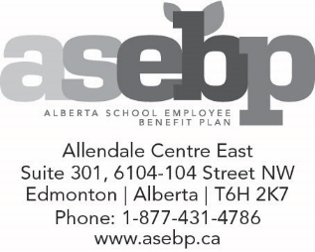 | ORAL HEALTH EXCEPTION REQUEST:  Permanently Disabled Over-age Dependant

INSTRUCTIONS:
- Please only use this form to request oral health exception for permanently disabled over-age dependants aged 19 and 20. All other requests should be made with the Oral Health Exception Request form.
- Please submit the completed form to ASEBP by fax at 888-895-6837 or email at OHE@asebp.ca.
- If you have any questions about the oral health exception process, please contact our ASEBP specialty claims coordinator at 780-431-4780.

Part 1: Patient Information

A. Patient Information
Last name: | First name: |  |  | ASEBP ID:
Address: |  |  | Date of birth (YYYY/MM/DD): / /
City: |  | Province: | Postal code: | Phone: - -

Diagnosis / Health State: | Date of initial diagnosis:  Month Year

C. Consent to Collection, Use and Disclosure of Personal Health Information
The personal information contained in this form (with any supporting documentation provided) and other personal information held by the Alberta School Employee Benefit Plan (ASEBP) is used to determine eligibility for this benefit and administer the benefit plan. It may be necessary for ASEBP to disclose your personal information related to this notification to a third party service provider. When third party service providers are retained, appropriate contracts are in place to protect personal information.
I understand why the information is required and am aware of the risks and benefits of providing this information. I consent to the collection, use and disclosure of my personal information for the purposes identified above. I understand that I may revoke my consent at any time and acknowledge that doing so will affect my/our eligibility to receive benefits related to this oral health exception request.
I agree this authorization shall be in effect from the date below and shall be valid for the duration of time required to manage this request.
I understand that by virtue of the provisions of the Personal Information Protection Act of Alberta, my dependants are deemed to consent to the collection, use and disclosure of their personal information for the purpose of enrolment in and coverage under the group benefit plans, through me as the applicant.
I agree to the above and declare that my statements in this form are complete, accurate and true.
Verbal consent will not be accepted, form must be signed by parent/guardian.
Parent/guardian signature: “First name Last name” Date:
Consent is being obtained in accordance with sections 7, 8, 9 and 61 of the Personal Information Protection Act of Alberta and section 1 of the federal Personal Information Protection Electronic Documents Act. Be advised that in order to optimize the services we provide we may use service providers outside Canada to carry out certain functions on our behalf. In such situations, we enter into contracts and/or verify that appropriate privacy and security protocols are in place. If you have any questions regarding the collection, use and disclosure of your personal information, please refer to ASEBP’s Privacy Policy at www.asebp.ca or contact the privacy officer at 780-438-5300.

Please be advised that further information may be requested if needed to facilitate determination of coverage.

